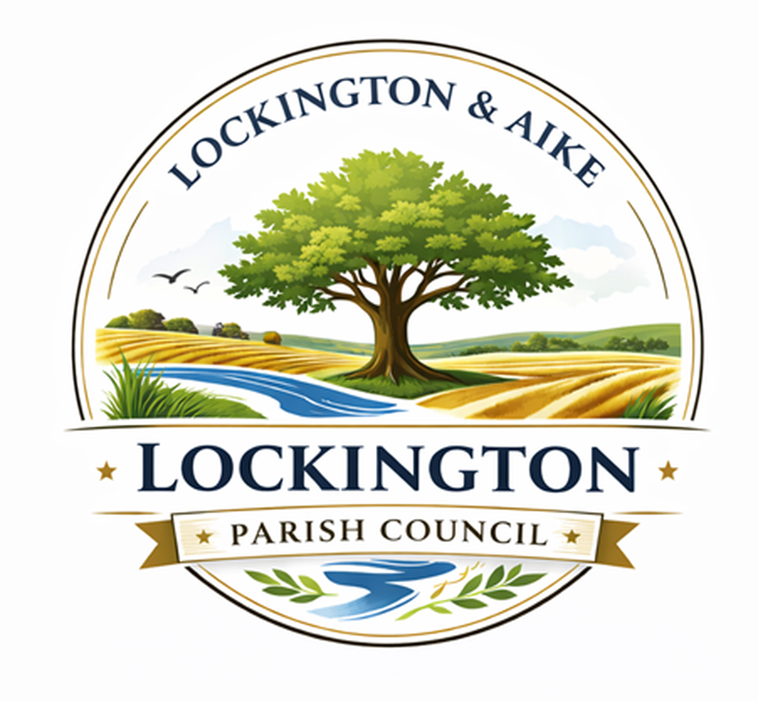
Lockington Parish Council
Meeting Agenda: Tuesday, 15th September 2026

Dear Sir/Madam,

I hereby give notice that an ordinary meeting of Lockington Parish Council will be held on Tuesday, 15th September 2026, at 7 p.m. at Lockington Village Hall. All members of the Parish Council are hereby summoned to attend and conduct the business set out below.

Members of the public and the press are encouraged to attend and share their views with the Parish Council during the Public Participation Period, which will occur towards the end of the meeting.

Agenda Items (Subject to amendment)

26-27/41 To receive Apologies:

26-27/42 (a) To approve the minutes of the Ordinary Parish Council Meeting held on 22nd July 2026.

26-27/42 (b) To approve the minutes of the Extraordinary Parish Council Meeting held on 11th August 2026.

26-27/43 (a) To receive and record any ‘Declaration of Interest’ (Pecuniary, Non-Pecuniary and/or Prejudicial Interest) from any Parish Council member in relation to the listed agenda items.

26-27/43 (b) To record the nature of the Declaration of Interest referred to above.

The Declaration of Interest should be made at the beginning of the meeting.

26-27/44 To review and resolve any business for the East Riding of Yorkshire Council (ERYC).

44.1 ERYC feedback from Ward Councillor Jeremy Wilcock.

26-27/45 Parish Council Ongoing Business Matters:

To review, debate, and agree on an action plan for each of the items listed below.

45.1 Dogger Bank ‘D’ (DBD) project update.
45.2 Clean Air Solar Farm (CASF) project update.
45.3 Hornsea 4 project update.
45.4 ERYC Scoping Consultation for the new ER Local Plan update.

- Scoping Consultation.
- Development of Lockington Neighbourhood Plan.

  - Children’s Play Area.

- Playdale capital cost and plan.
- Play area Financing/Grants.
- Siting of Play Area.
- Cleaning Regime for Play equipment.

  - Village Green

- Thorpe and Beckside hedge timing plan.
- Wildflower & Planting – forward plan.
- Assistance article in the Gazette.

  - Asset Audit Feedback.
  - LAVIG Forward Plan.
  - Parked Cars on Front Street (Restricting emergency vehicles).

26-27/46 Correspondence/Clerk.

To review, debate, and agree on an action plan for each of the items listed below.

46.1 DBD Onshore Targeted Statutory Consultation – email sent 23.7.26.
46.2 CASF Scoping Report - Draft Submission – email sent 23.7.26.
46.3 Scoping Consultation for the new East Riding Local Plan – email sent 23.7.26.
46.4 Parishioner Correspondence – Condition of Ford crossing Front Street/Chaple Street – email sent 29.7.26 (ERYC Highways reference – 2358861)
46.5 Hornsea 4 Newsletter August 2025 – email sent 31.7.26.
46.6 DBD Liaison Group Minutes - 18th June 2026 – email sent 31.7.26.
46.7 ERNLLCA August Newsletter – email sent 6.8.26.
46.8 Object to Exploratory Gas Drilling - Egdon Resources Ltd Planning Application NY/2025/0113/FUL - email sent 26.8.26.
46.9 EA – Bryan Mills Beck Cleaning Regime - email sent 27.8.26.

26-27/47 Planning – All

To review and submit observations on the following Planning Applications and Approvals.

47.1 26/01191/PLF - 6 Rectory View Lockington East Riding of Yorkshire YO25 9SG - Erection of a single storey extension to rear, first floor extension to side, and porch to front.
ERYC has resolved to grant planning permission.

47.2 26/00831/PLF - Land East of Ashford House Chapel Lane Aike East Riding of Yorkshire YO25 9BG - Erection of a wildlife tower and siting of a shepherd's hut.
ERYC has resolved to grant planning permission.

47.3 26/00830/PLF - Land East of Ashford House Chapel Lane Aike East Riding of Yorkshire YO25 9BG - Construction of a wildlife pond (retrospective) and erection of a workshop for the storage of equipment and providing sheltered space for planting, processing and packaging produce.
ERYC has resolved to grant planning permission.

47.4 26/01317/PLF - 20 Rectory View Lockington East Riding of Yorkshire YO25 9SG - Erection of two storey extension to side following demolition of existing. ERYC has resolved to grant planning.

47.5 26/01998/TCA - 12 Front Street Lockington East Riding of Yorkshire YO25 9SH - Crown reduce 1 no. Silver Birch tree (T1) by 3 metres and crown lift by 0.9 metres due to feathery tertiary branches; Crown reduce 1 no. Silver Birch trees (T2) by up to 1.5 meters. LPC to Consider – No Observations.

26-27/48 Finances

48.1 To review, debate and approve the financial items listed below.

Date | Description | Transaction Type | Amount
12.8.2026 | Goalposts for Village Green | BT | - £78.99
19.8.2026 | Pre Planning Application for  Beckside Hedge | BT | - £78.00
25.8.2026 | Fisk Printers Issue 159 | BT | - £89.00

26-27/49 Public Participation Period - Items for Next Agenda

26-27/50 Date of next Meeting

Ordinary Parish Council Meeting (OPCM) on Tuesday, 20th October 2026, at 1900 hrs at the Village Hall.

Issued by;
Gareth Rees
Clerk to Lockington Parish Council
Mobile: 07768233352
email: clerk@lockingtonparishcouncil.gov.uk

